**HOW TO CREATE AN ANIMATION**

TABLE OF CONTENTS.

Purpose……………………………………………………………………………………………….1

Types of animations …………………………………………………………………………….1

Platforms used………………………………………………………………………………………,2

Programming languages used………………………………………………………………2

Purpose

This document gives abelief guideline of the creation of animations or cartoons such as Naruto, bleach or tom and jerry and animated graphics

It lists the languages that are needed and the platforms onto which they can be created

It also gives which audiences are interested and where step by step learning material can be found

We will first go through;

1:what types of animations there are.

2: what type of platforms are ideal for creating which animations types.

3: which languages are needed.

4: references for learning material.

Types of animations

After researching the topic or idea of creation animations a conclusion on the different types of animations was that the animations types take up the different types of drawing view that is third dimension view and second dimension which are vector based. plus, motion graphics that is to say animated logos.

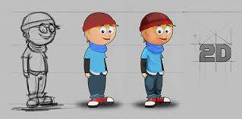 2d animations

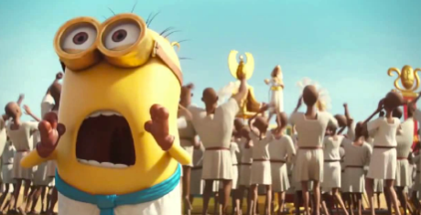 3D animation

Platforms used

1. Blender: blender is a very helpful tool in 3D modeling. Its tools help in UV unwrapping, texturing, raster graphics editing, rigging and skinning, fluid and smoke simulation, particle simulation, soft body simulation, sculpting, animating, match moving, camera tracking, rendering, video editing and compositing. Blender can be installed on machines with good graphics cards and RAM of at least 2GB. When creating animations that is to say human avatars, one has to start by modeling the avatar that is the shape of the avatar. Blender also helps in rigging of the animations movements and texturing. Another tool that can be used in creation of an animation is adobe photo shop which can help in the perfection or improvement of image quality that is the texturing. Video teaching the use of this plat form can be found on YouTube
2. Cinema 4D: this is a 3D modelling, animation, motion graphics and rendering application. It might be simpler than blender since then modelling of objects is not as complex as it is in blender. That is some objects are already created within the plat forms. This platform is ideal for 3D animations. Just like blender educational videos of its usage are plentiful on YouTube.
3. Adobe After effects: this is a visual effects and motion graphics applications created by adobe systems. It is ideal for creating motion graphics that is animated logos.
4. adobe animate cc. this is an application created by adobe systems in the adobe suit. It can be used to create both 2D and 3D animations or cartoons. It can be downloaded from the adobe cloud. Tutorials on its usage can be got from YouTube. It’s easy to learn and fun to use for someone interested in animating cartoons

Programming languages used

Blender uses python for internal scripting.

Cinema 4d used its own scripting language know as C.O.F.F.E.E and it can also use python.